Homework: Regression and Smoothing 2D Domain

Due: 9 points

Revise the plot in 3.3

# 2: Plot of choice

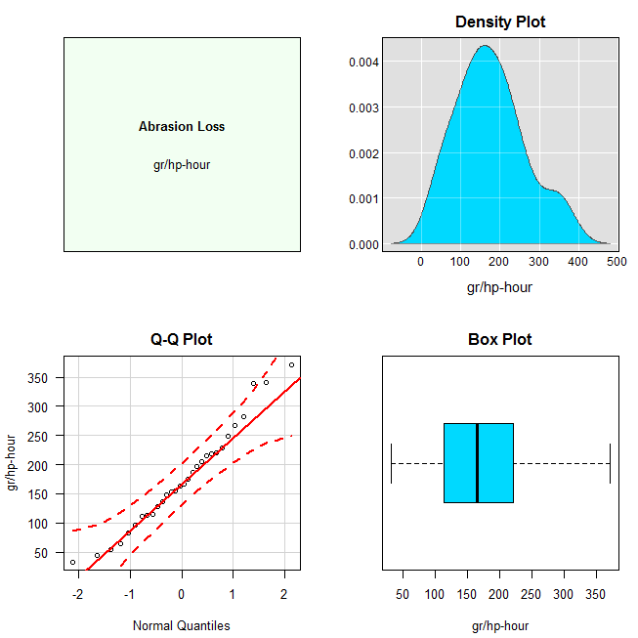

# 3: Plot

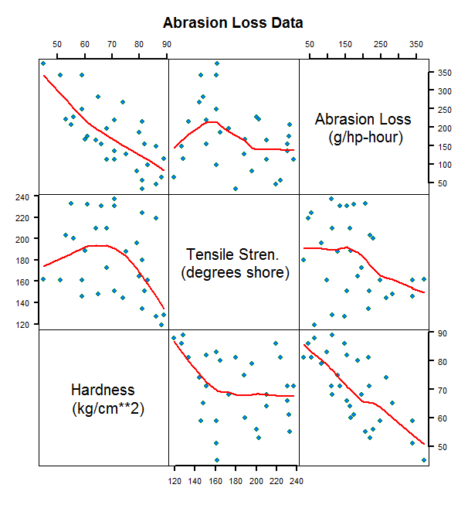

# 4: Plot

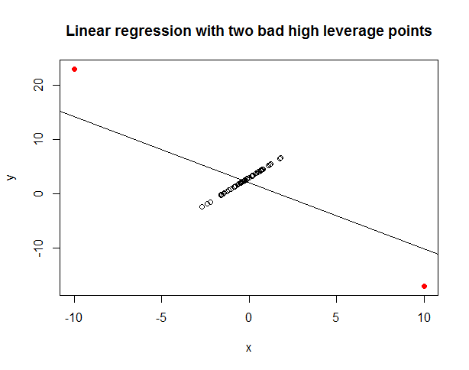

# 6.1: Plot of Choice

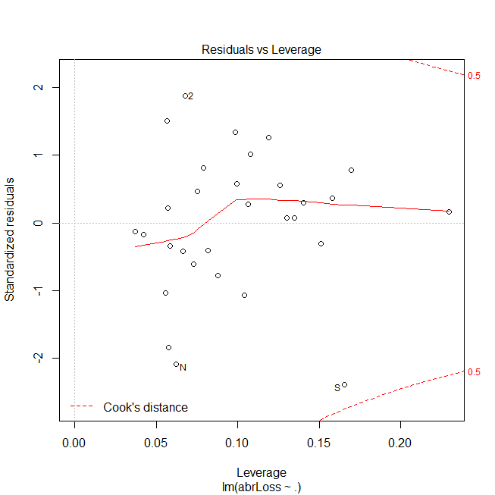

# 6.2: Plot

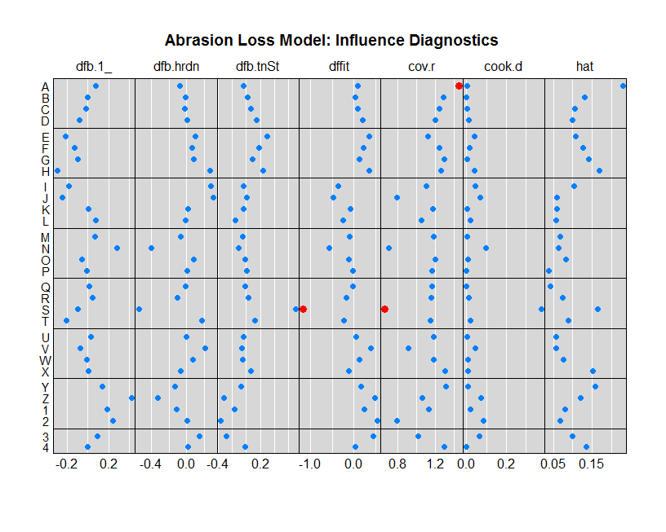

# 6.4: The Spread-Location Plot

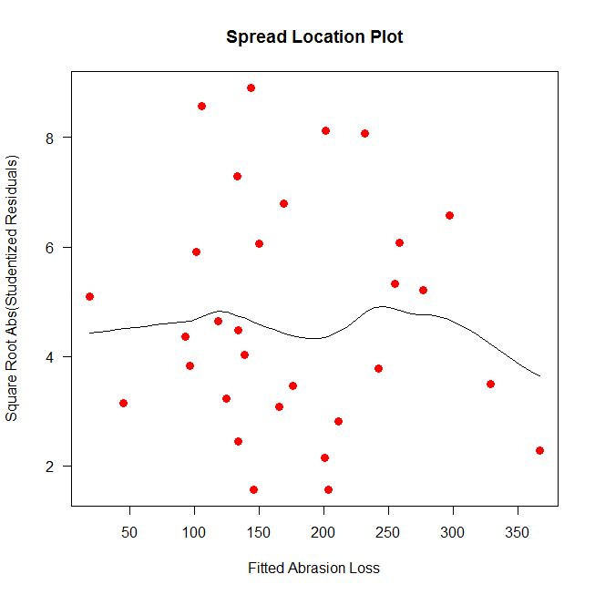

# 6.5: The detrended partial residual plot for adjusted tensile strength

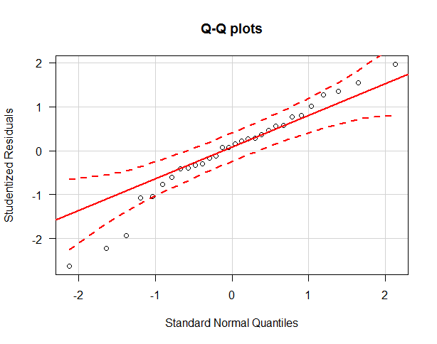

# 7.3: A draped wireframs plot, your choice and the contour plot

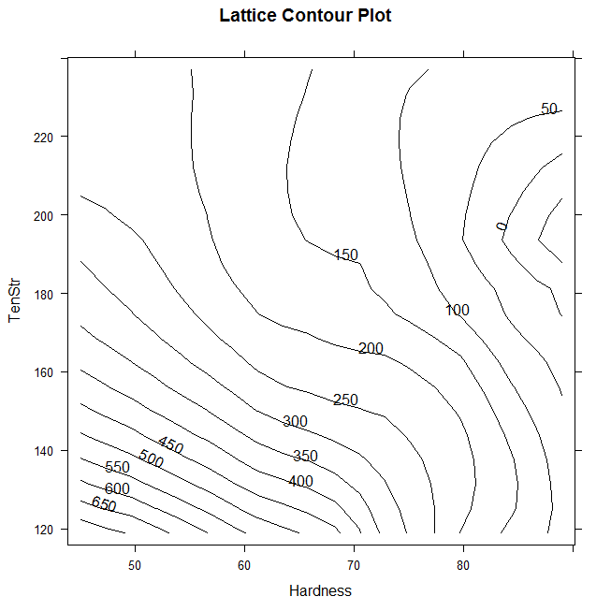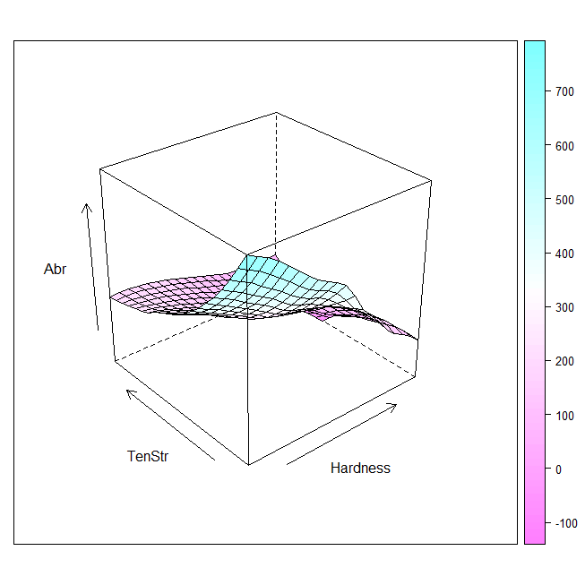

# 8: The coplot of abrasion loss vs. Tensile strength given hardness

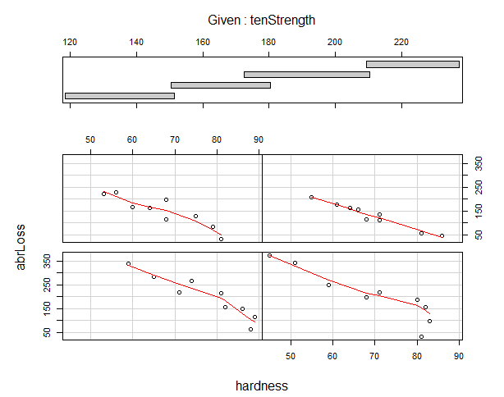

Homework: Hitters

Due: Plots 2.1 and 2.3

# 2.1:

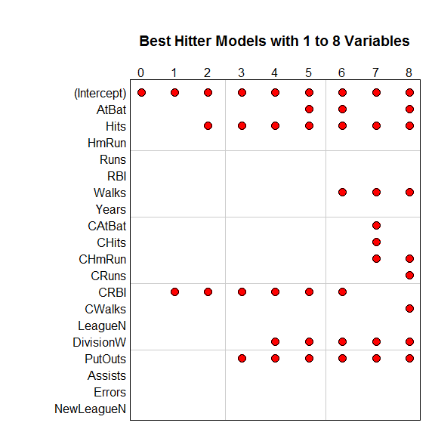

# 2.3:

